Wine Review Natural Language Processing with LDA and Doc2Vec
Despite similar point scores on average, Established regions are described as “good” more often, and having “supremely” qualities, showing how language is used to shape reviews for regions. Up and Coming wines are more likely to be called “flabby.”

Up and Coming wines are more often described with words like “fresh”, “lemon”, and “apple” compared to Established wines.

These findings from a recent project are all created using natural language processing methods. The project used LDA to statistically analyze 120,000 wine reviews from a U.S. based magazine, with the goal of testing how different regions were covered. The technology behind this is straightforward and can be used for many applications. The following provides a rundown on what was used, the workflows, considerations for parameter setting, applications, and some of the pros and cons of use. I also sketch out the doc2vec model as a potential solution to some limitations of the LDA model.

LDA
Latent Dirichlet Allocation (LDA) is a three-layered hierarchical Bayesian model used in natural language processing. The three layers are the corpus, or the total collection of documents, a fixed number of topics, and a distribution of words. The central idea is a set number of topics exists which can be created by the probability of words occurring, and topics can belong to one or many different documents in the corpus. LDA is a common method used for semantic mining and creating recommendation systems, similarity detection for plagiarism systems, or sentiment analysis of online communities.

Workflow
The code for this project can be viewed at this GitHub link, and includes data, code, and documents related to the project.

Data cleaning
Given the nature of natural text, it is important to standardize the data before analysis. For this project, I transformed the text to lower case, removed punctuation, numbers, stop words, and any whitespace. Stop words are things like “a”, “the”, and “is” which connect subjects with different verbs and adjectives, but offer little insight when counting the probabilities of certain words appearing. For instance, knowing “a” has a very high probability of appearing tells us little, and reduces the accuracy of topics. I also chose to lemmatize the text, rather than stemming. Lemmatization uses a dictionary to reduce the numbers of words to a base element, i.e. “oaky” becomes “oak.” This allows for better language understanding, which is more valuable in a text study like this with complicated language use. Stemming, which would simply remove endings to different works, leads to better results in applications like search engines which need fast results. The words also become less decipherable, because non-words are created like “ubiquitously” becoming “ubiquit-.” The R code below uses the tm “text mining” package to make these transformations. Finally, the raw text is inserted into a document term matrix “DTM”. See the R code below.
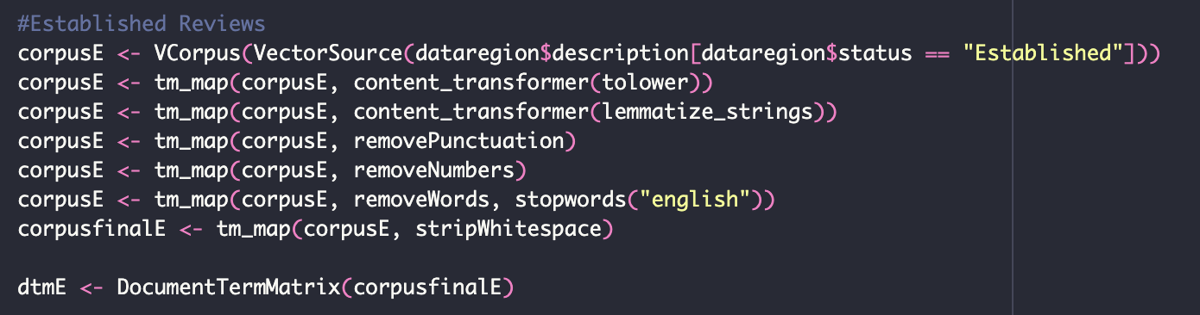

Splitting of groups
For the purpose of this research question, “how do wine reviewers function as gatekeepers when describing wines from different regions?” two categories of data are required. The study aims to examine what happens when reviewers describe new Up and Coming regions which do not have an established reputation. There are two portions to this step, the first is creating the criteria for what is “Established” and what is “Up and Coming” and the second is implementing this through creating new columns in R for each of the reviews in the dataset.

It quickly became apparent that there were many more regions than I had familiarity with. Although the most popular regions for reviews were straightforward to guess— California, Bordeaux, Tuscany, Oregon – many could easily be considered Up and Coming. I first split the groups into two based on my general idea of what is Up and Coming, especially considering the dataset is from 2020 so many of the trends post covid in wine like rising popularity for Greek, Mexican, and Chinese wines hadn’t occurred yet. To create objectivity, I examined 4 years’ worth of top 100 lists from wineenthusiast.com, the same source of the reviews. I then included any regions which were listed here as established, given the top placement in the list. Notably, the wines of the Finger Lakes in New York State were included, so they are moved into the Established category, while other wines from long island for instance remain in Up and Coming. This achieves the effect of bringing the categories more in line with the same reviewers from the data set. It should also be noted that due to wines becoming unavailable over time, or removed from the website, many entries were omitted from the archived top 100 lists. What remains is a list of approx. 250 wines with region meta data.

Some wine regions were omitted because the categories were too vague, such as “Spain other” “table wine” or “other.” Each category was scanned to make sure there was not region-specific information which may be extracted into other categories. The different columns were then created using the dplyr package, see below for the R code.
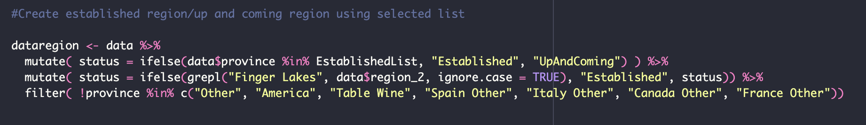

Train LDA model
In order to train the LDA model, I used the topicmodels package in R with the LDA() function, resulting in two models for established and up and coming, LDAe and LDAu respectively. A K value of 3 was selected for both models. This was because wine reviews typically cover the aroma, taste, and body of a wine. This fits well within 3 categories. Through testing, it appears the increasing the k value didn’t create new meaningful categories. See the R code below for a demonstration.
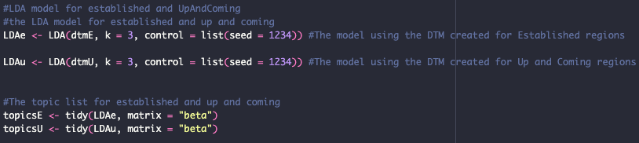

Interpretation
After training, the results were extracted and analyzed using the tidytext package function tidy() to obtain the β (beta) probabilities. This represents the probability of each word belonging to each of the three topics. The code was then sliced and printed to show the top and bottom terms, providing the most and least likely terms to appear.

Considerations for selecting parameters, evaluating performance statistics, and selecting representative examples
When looking at topics and term frequencies, there are many dimensions of the data which can disrupt potential analysis besides the data cleaning steps discussed previously. The dataset itself will include anomalies, especially at the scale of 120,000 reviews, which includes misspellings, non-English words, or unique phrasings. When examining terms, I omitted looking at statistically unlikely words that are simply anomalies instead of frequently used terms.

I also examined to matching the k value to the lowest level of perplexity if applicable. Wine reviews in this instance have a few common terms but many, many different terms, leading to high level of perplexity. If 0-50 is standard, this model was showing 900 – indicating a wide range of possible terms which can be included in a review. This follows with the unique vocabulary of wine reviews, and is important to consider when looking at language use in specialized domains.

Applications
Topic modelling is common in recommendation systems, similarity detection for plagiarism, or sentiment analysis. In this case, it is helpful to show the difference between two groups within the data, and pull distinct observations. The LDA model is great for revealing hidden linguistic differences between predefined groups. Here, it revealed the prevalence of the use of the term “good” to describe established wines compared to up and coming wines, despite the mean point rating being nearly the same for the two regions.

It could also be used to analysis the average topic weight profile of each reviewer, and see if a reviewer consistently emphasized aspects (like using “oak” as a descriptor more commonly.) The text values can also be compared and correlated with quality indicators of the wine. It can be determined which descriptive language is most valued by the market by looking at price, or the reviewer with a correlation to points. LDA also is the basis for recommendation systems. It allows the matching of users to information. In this case, if a user enjoys wines with a topic area of taste and fruit, they can be recommended wines that respond with many reviews from that topic.

Pros/cons
Pros:
- LDA models provide for interpretable topics made up of related words. Compared to other NLP methods, this allows for easier explanation to stakeholders who are interested in the findings.
- LDA models also perform soft clusters, through providing a distribution of topics for each document. Unlike hard clusters, topics can belong to documents simultaneously, which grasps the nature of real world language better. For instance, a wine isn’t just the aroma topic “A”, it can contain a percentage of topic A and B.
- LDA models also reduce the dimensionality of the document term matrix into more usable elements. This allows for using the topic weights in other applications like predictive modelling.

Cons:
- There are two main cons when using LDA models like this. First, the k value is selected based on judgement, not statistical likelihood. This requires an understanding of the domain, or running some tests like perplexity to understand the language used and what helpful topics would look like. Without informed judgment, it is possible to get topics with little explanatory power.
- Second, the LDA model doesn’t consider the semantic order of words. It instead looks at term frequencies, which loses explanatory power when looking at phrases of terms which have different meanings. This struggles with phrases like, “this wine is not good” because it cannot decipher the value of “not” in this context.

Doc2Vec
Doc2Vec is an unsupervised NLP model which creates embeddings of documents. These embeddings, which processes words and documents into unique numerical vectors, can be compared to others. This can then be used to find similar documents or cluster documents in a large corpus to find similarities.

Data Cleaning
The Doc2Vec model follows a similar data cleaning workflow as the LDA model. A unique identifier, the text, and the region status (Established or Up and Coming) are gathered in a data frame. Then text is transformed into a state for modelling, which includes changing it to lowercase, trimming white space, and removing punctuation and non-alphabet characters. Notably, I do not stem or lemmatize the text in order to retain the semantic meaning connecting words together. See below for the R code.
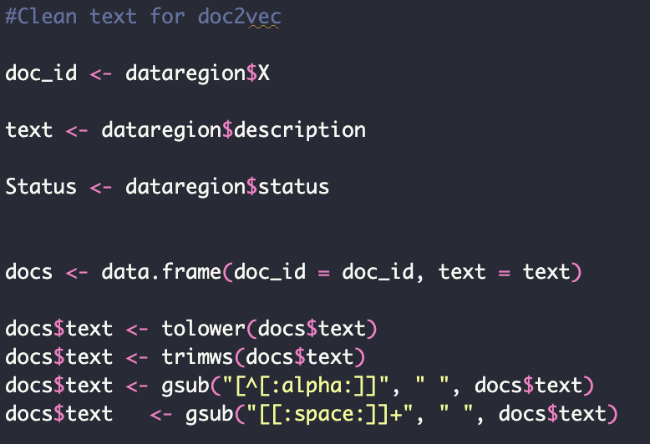

Then the paragraph2vec function is run, selecting the data frame and choosing the distributed memory type (PV-DM) instead of a bag of words type which would function like an LDA model and count term frequencies. Dimensions controls for how large the vector is, as it considered more dimensions. Iterations selects how many passes it takes through the data set to get the final vector. Min_count allows you to select a threshold for which words to include, omitting some that are not frequently mentioned. And window allows for controlling how many words near a given term are considered, in this case 5 words before and 5 words after. These parameters are shown in the R code below.

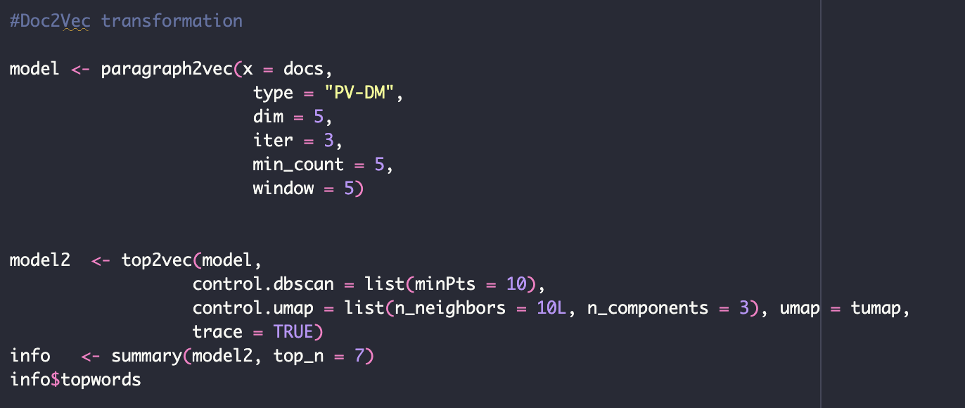

Considerations for selecting parameters, evaluating performance statistics, and selecting representative examples
This model ultimately collapsed due to the high computation needs. I selected small parameters to attempt a minimum viable product, but this still did not work with the equipment available. In the future, I would increase the dimensions up to 50 for better semantic understanding.

Applications
Doc2Vec allows for findings new similarities between documents than would otherwise be possible. In the case of wine review, it is possible to see similarities between varieties and regions that otherwise are not noted. It also allows for seeing different patterns of phrases for wines that have lots of faults but one or two strengths, or vis versa. The 3d vector space can also be used to identify outliers that are far away from the main clusters, which is useful for identifying things like particularly bad reviews or data quality issues.

Pros/cons
Pros:
- Doc2Vec can capture the semantic meaning of entire documents in a corpus unlike methods like LDA. Documents with similar vectors can be analyzed and grouped together, and clustering can be done. Where the LDA model couldn’t interpret “the wine is good”, a Doc2Vec model can.
- The vectors can then be used in further analysis like correlation testing, linear regression, or classification algorithms.
Cons:
- Doc2Vec models are resource intensive. The model requires lots of computational power and time to train sufficiently. In this project, the model crashed when converting to a topic summary, due to more than 80gb of memory processing being required. With the right equipment, this limitation can be overcome.
- Doc2Vec struggles with out of vocabulary words when trained on specialized data sets. For instance, the term covid in a model trained before covid or rare words are not vectorized very well.

References

Ali, Héla Hadj, et al. “The Impact of Gurus: Parker Grades and En Primeur Wine Prices.” Journal of Wine Economics, vol. 5, no. 1, 2010, pp. 22–39. DOI.org (Crossref), https://doi.org/10.1017/S1931436100001358.
Ashenfelter, Orley. “Predicting the Quality and Prices of Bordeaux Wine.” The Economic Journal, vol. 118, no. 529, Jun. 2008, pp. F174–84. DOI.org (Crossref), https://doi.org/10.1111/j.1468-0297.2008.02148.x.
Barzilai‐Nahon, Karine. “Toward a Theory of Network Gatekeeping: A Framework for Exploring Information Control.” Journal of the American Society for Information Science and Technology, vol. 59, no. 9, Jul. 2008, pp. 1493–512. DOI.org (Crossref), https://doi.org/10.1002/asi.20857.
Bourdieu, Pierre, and Pierre Bourdieu. Distinction: A Social Critique of the Judgement of Taste. 11. print, Harvard Univ. Press, 2002.
Dhananjaikrishnakumar. “Limitations of Word2vec.” Medium, 23 Apr. 2025, https://medium.com/@dhananjaikrishnakumar/limitations-of-word2vec-33db20ac63cc.
“Doc2Vec in NLP.” GeeksforGeeks, 11 July 2023, https://www.geeksforgeeks.org/nlp/doc2vec-in-nlp/.

Kopsacheilis, Orestis, et al. “Crowdsourcing the Assessment of Wine Quality: Vivino Ratings, Professional Critics, and the Weather.” Journal of Wine Economics, vol. 19, no. 3, Aug. 2024, pp. 285–304. DOI.org (Crossref), https://doi.org/10.1017/jwe.2024.20.
Lecocq, Sébastien, and Michael Visser. “What Determines Wine Prices: Objective vs. Sensory Characteristics.” Journal of Wine Economics, vol. 1, no. 1, 2006, pp. 42–56. DOI.org (Crossref), https://doi.org/10.1017/S1931436100000080.
Lewin, Kurt. “Frontiers in Group Dynamics: II. Channels of Group Life; Social Planning and Action Research.” Human Relations, vol. 1, no. 2, Nov. 1947, pp. 143–53. DOI.org (Crossref), https://doi.org/10.1177/001872674700100201.
Masset, Philippe, et al. “Fine Wine Pricing in a Small and Highly Competitive Market.” International Journal of Wine Business Research, vol. 35, no. 1, Feb. 2023, pp. 164–86. DOI.org (Crossref), https://doi.org/10.1108/IJWBR-10-2021-0054.
Masset, Philippe, and Steffen Raub. “The Impact of Wine Tasters’ Expectations on Wine Quality Ratings and Willingness-to-Pay.” Journal of Wine Economics, vol. 18, no. 2, May 2023, pp. 156–72. DOI.org (Crossref), https://doi.org/10.1017/jwe.2023.15.
Installation. R-Packages, https://cran.r-project.org/web/packages/doc2vec/readme/README.html. Accessed 8 Dec. 2025.
Storchmann, Karl. “Wine Economics.” Journal of Wine Economics, vol. 7, no. 1, May 2012, pp. 1–33. DOI.org (Crossref), https://doi.org/10.1017/jwe.2012.8.
Yang, Chenyu, et al. “Wine Review Descriptors as Quality Predictors: Evidence from Language Processing Techniques.” Journal of Wine Economics, vol. 17, no. 1, Feb. 2022, pp. 64–80. Cambridge University Press, https://doi.org/10.1017/jwe.2022.3.

https://tiny.pratt.edu/6rSdfCcIX
Yang, Chenyu, et al. “Wine Review Descriptors as Quality Predictors: Evidence from Language Processing Techniques.” Journal of Wine Economics, vol. 17, no. 1, Feb. 2022, pp. 64–80. Cambridge University Press, https://doi.org/10.1017/jwe.2022.3.
Jelodar, Hamed, et al. "Latent Dirichlet allocation (LDA) and topic modeling: models, applications, a survey." Multimedia tools and applications 78.11 (2019): 15169-15211.
“Doc2Vec in NLP.” GeeksforGeeks, 11 July 2023, https://www.geeksforgeeks.org/nlp/doc2vec-in-nlp/.
Installation. R-Packages, https://cran.r-project.org/web/packages/doc2vec/readme/README.html. Accessed 8 Dec. 2025.
Dhananjaikrishnakumar. “Limitations of Word2vec.” Medium, 23 Apr. 2025, https://medium.com/@dhananjaikrishnakumar/limitations-of-word2vec-33db20ac63cc.

